Temasek Polytechnic

School of Informatics and IT

**Diploma in Information Technology (IT)**

Project Plan

**Project Particulars**

|  |  |
| --- | --- |
| **Tutor** | Mr Mel Goh |
| **Class** | P02 |
| **Project Title** | Delonix Regia Hotel Management System |

**Project Team’s Particulars**

|  |  |
| --- | --- |
| **Matric Number** | **Student Name** |
| 1500564H | Shawn Yang |
| 1502728G | Xavier See |
| 1500340C | Yeo Kai Sheng |
| 1500858D | Yeo Ai Ling |

**Table of Contents**

Revision History 3

Project Plan 4

1. Introduction 4

1.1. Objectives and scope of the project 4

Objectives 4

Scope of the project 4

1.2. Assumptions and constraints 4

1.1.1. Assumptions 4

1.1.2. Constraints 5

1.3. Definitions and acronyms 5

2 Roles and responsibilities 6

3. Estimates and project schedule 7

3.1. Work breakdown structure 7

3.2. Project Schedule 8

3.3. Budget Summary 14

4. Risk Management Plan 16

# Revision History

|  |  |  |  |
| --- | --- | --- | --- |
| **Date** | **Version** | **Description** | **Author** |
| 4/5/2017 | v1 | Objectives & Scope | Kai Sheng |
| 5/5/2017 | v1.1 | Assumptions & Constraints | Ai Ling |
| 6/5/2017 | v1.2 | Definitions & Acronyms | Xavier |
| 7/5/2017 | v.1.3 | Project Schedule | Shawn |
| 8/5/2017 | v1.4 | Risk Management | Ai Ling |
| 9/5/2017 | v1.5 | Roles & Responsibilities | Kai Sheng |
| 10/5/2017 | v1.6 | Work Breakdown Structure | Xavier |
| 10/5/2017 | v1.7 | Budget Summary | Kai Sheng |
| 10/5/2017 | v1.8 | Definitions & Acronyms  Project Schedule | Shawn |
| 11/5/2017 | v1.9 | Table of Content  Assumptions & Constraints | Shawn |
| 11/5/2017 | v2.0 | Work Breakdown Structure | Xavier |
| 11/5/2017 | v2.1 | Objectives | Kai Sheng |
| 12/5/2017 | v2.2 | Definitions & Acronyms  Project Schedule  Tables of Content | Shawn |

# Project Plan

# Introduction

## Objectives and scope of the project

### Objectives

The objective of the project is to develop a hotel management system for Delonix Regia Hotel. The system should be able to handle reservations, payment, housekeeping, and finance accounting. Overall, the system should enhance hotel operations, meet hotel needs and serve customer needs better.

### Scope of the project

It would allow Mr and Mrs Wang to advertise and promote hotel packages and reserve rooms for guest. Hotel reservations can be made through online booking, both website and mobile devices. There should be housekeeping and maintenance management as well as staff management to keep track the staff’s schedules.

There is different payment option for customer to choose. Guest details are also combined into the hotel system, as long as they give their identification card to scan into the system, it would show the past record of the guest.

## Assumptions and constraints

### Assumptions

Assumptions are events that might happen but does not has any proof yet.

Assumptions:

* There are capable programmers to finish the project
* There is decent resource to make sure that the process of the project procedures is smooth.
* Project will not exceed the budget given.
* Project will be finished by the planned deadline day
* Project will not exceed the duration given for project development
* At some point in the near future we should be able to meet with our fellow stakeholders in the company regarding our project
* We have the necessary equipment and software to carry out the project provided by the company
* Various networks, software communications tools and software tools would be available to us by the company
* The facilities such as project rooms and data centres should be available to us for the use of the project
* Our project team assumes that the Mr Wang’s company has a clear idea of what type of architectural and design approach they would want us to take.

### Constraints

Constraints are restriction imposed of the project. It includes, resources, cost or schedule.

Constraints:

* Insufficient resources will cost the delay in delivering the project
* Cost will rise due to the lack of resources needed
* Insufficient material accessible to complete the software
* Conflicting in scheduling of the groupmates
* An imposed design approach or conditions imposed that is beyond the project capabilities
* Restrictions on the use of facilities such as project rooms and data centre
* Lack of sufficient manpower to carry out the project
* Company policies and regulations that would restrict project options
* Imposed software requirements specification methodology
* Physical constraints like constricting floor space available for project development
* Constricting procurement and purchasing policies & regulations
* Risk constraints such as restrictions on the amount of risk sponsors of this project are willing to take
* Imposed technology constraints that is beyond the capabilities of the project development

## Definitions and acronyms

|  |  |
| --- | --- |
| Acronyms | Definitions |
| SDLC | Software Development Life Cycle |
| ADE | Activity Duration Estimation |
| RAT | Reserve Analysis Technique |
| IT | Information Technology |
| SRS | Software Requirements Specification |
| 3rd Party | 3rd party source is an external partner you may work with from outside the company |
| Cloud Storage | Cloud storage is a remote server that in which data is stored accessed and maintained on the internet |
| Agile Model | Agile model which is a SDLC model is a combination of incremental and iterative processes whose main aim is process adaptability and customer happiness by quick delivery of a software system |
| Rational Functional Tester | A software tool used for the automated testing of software applications |
| Base7Booking | This is the current number 1 integrated property management software system |

# Roles and responsibilities

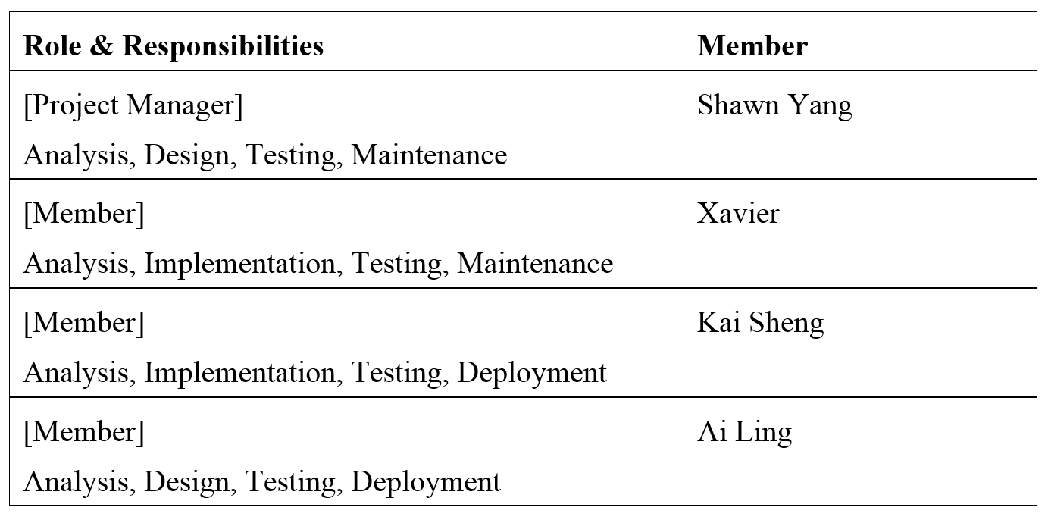

# Estimates and project schedule

## Work breakdown structure

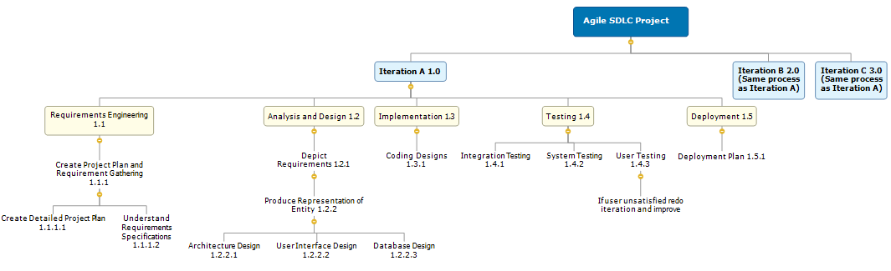

Each iteration will take roughly 19 days to complete, all members are involved in iterations

Requirement Engineering - 2 Days

Analysis and Design - 3 Days

Implementation - 10 Days

Testing - 3 Days

Deployment - 1 Day

## Project Schedule



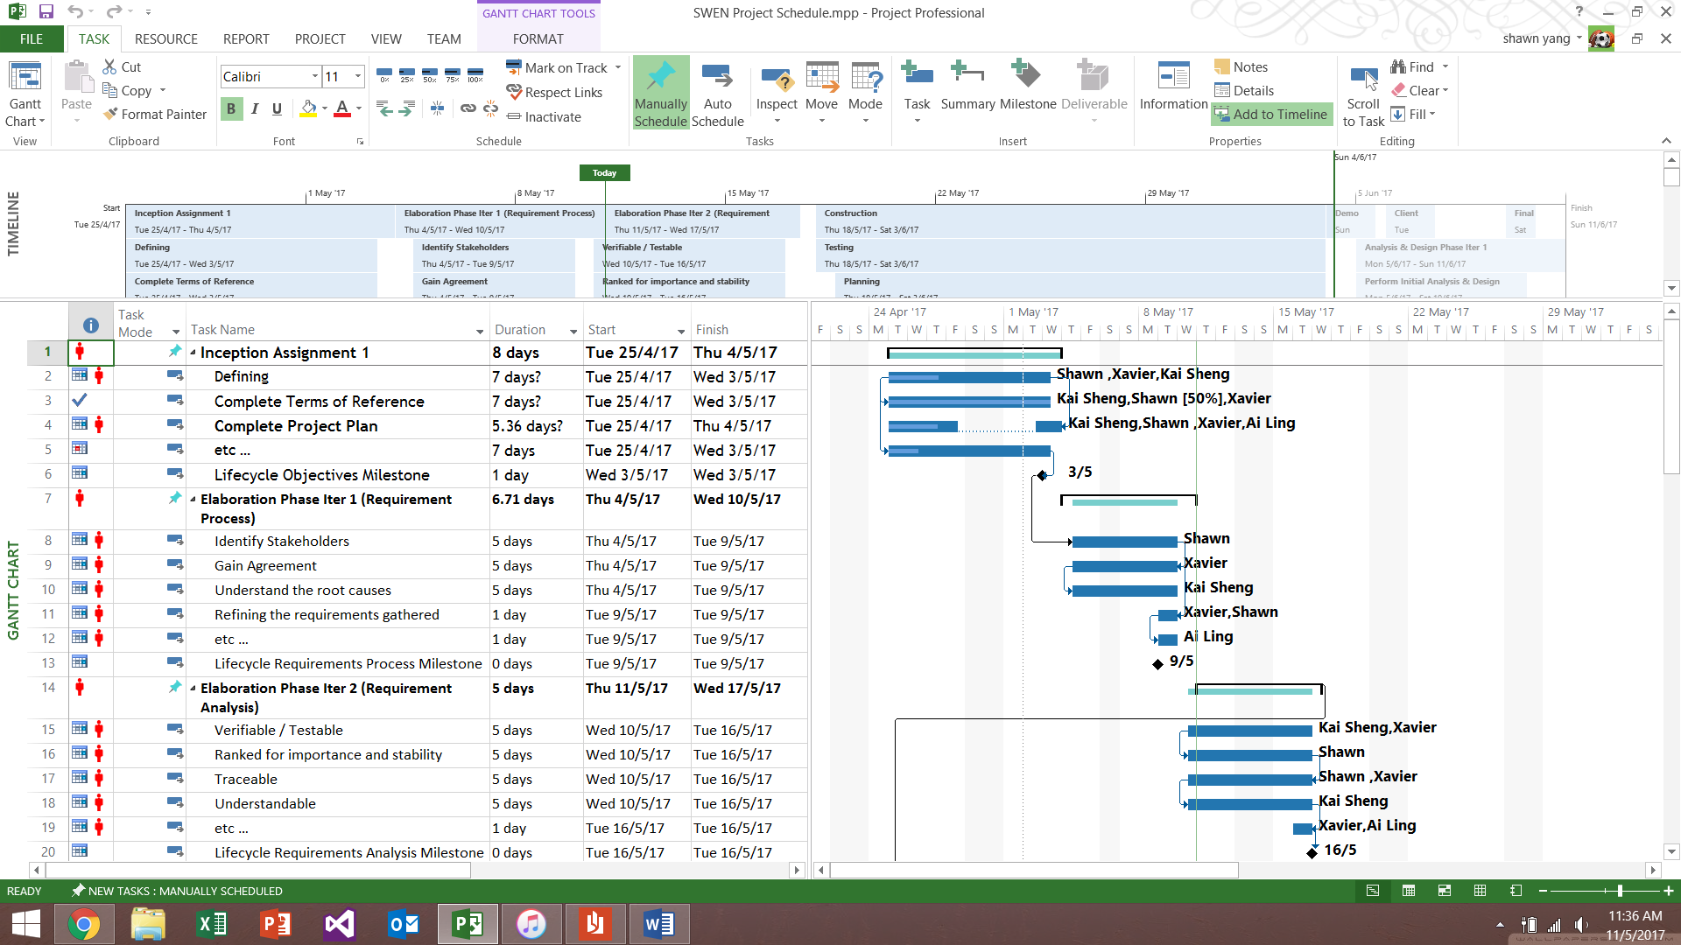

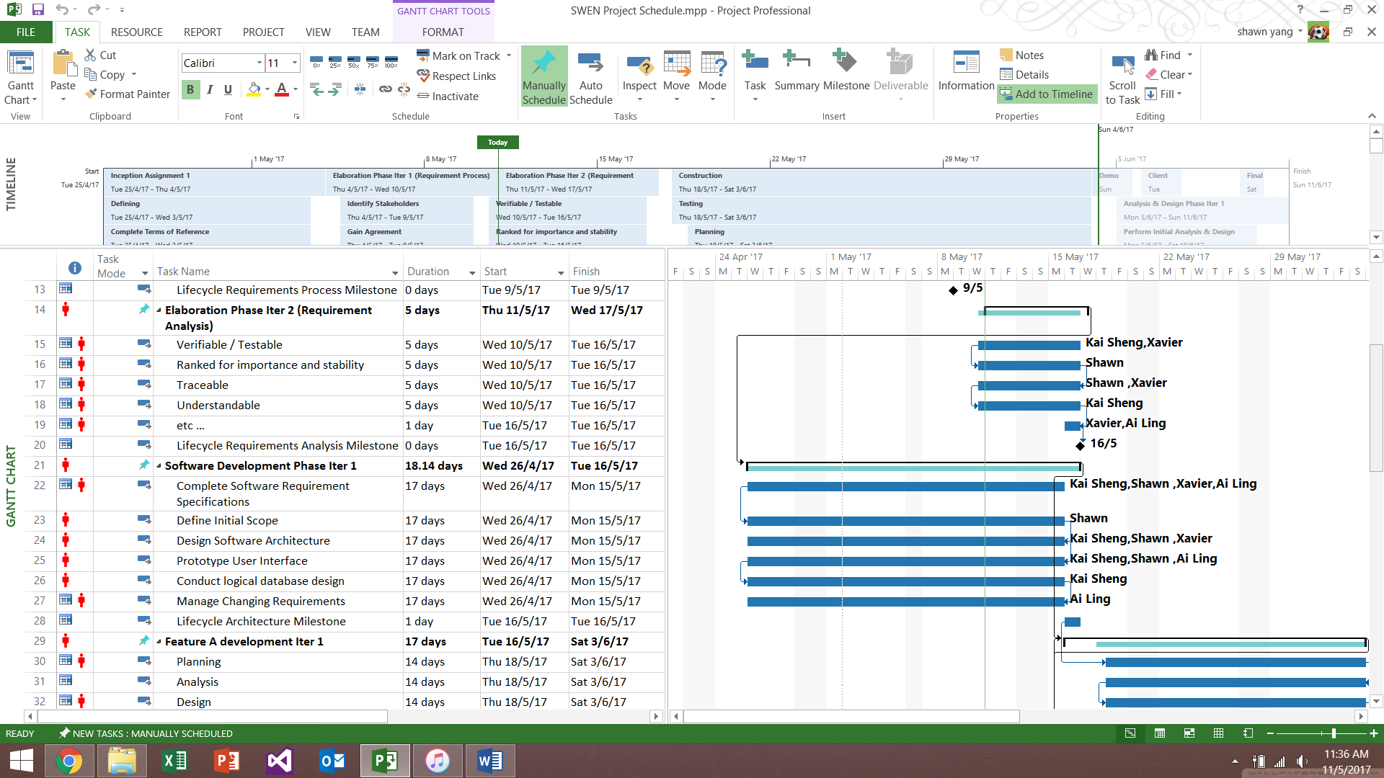

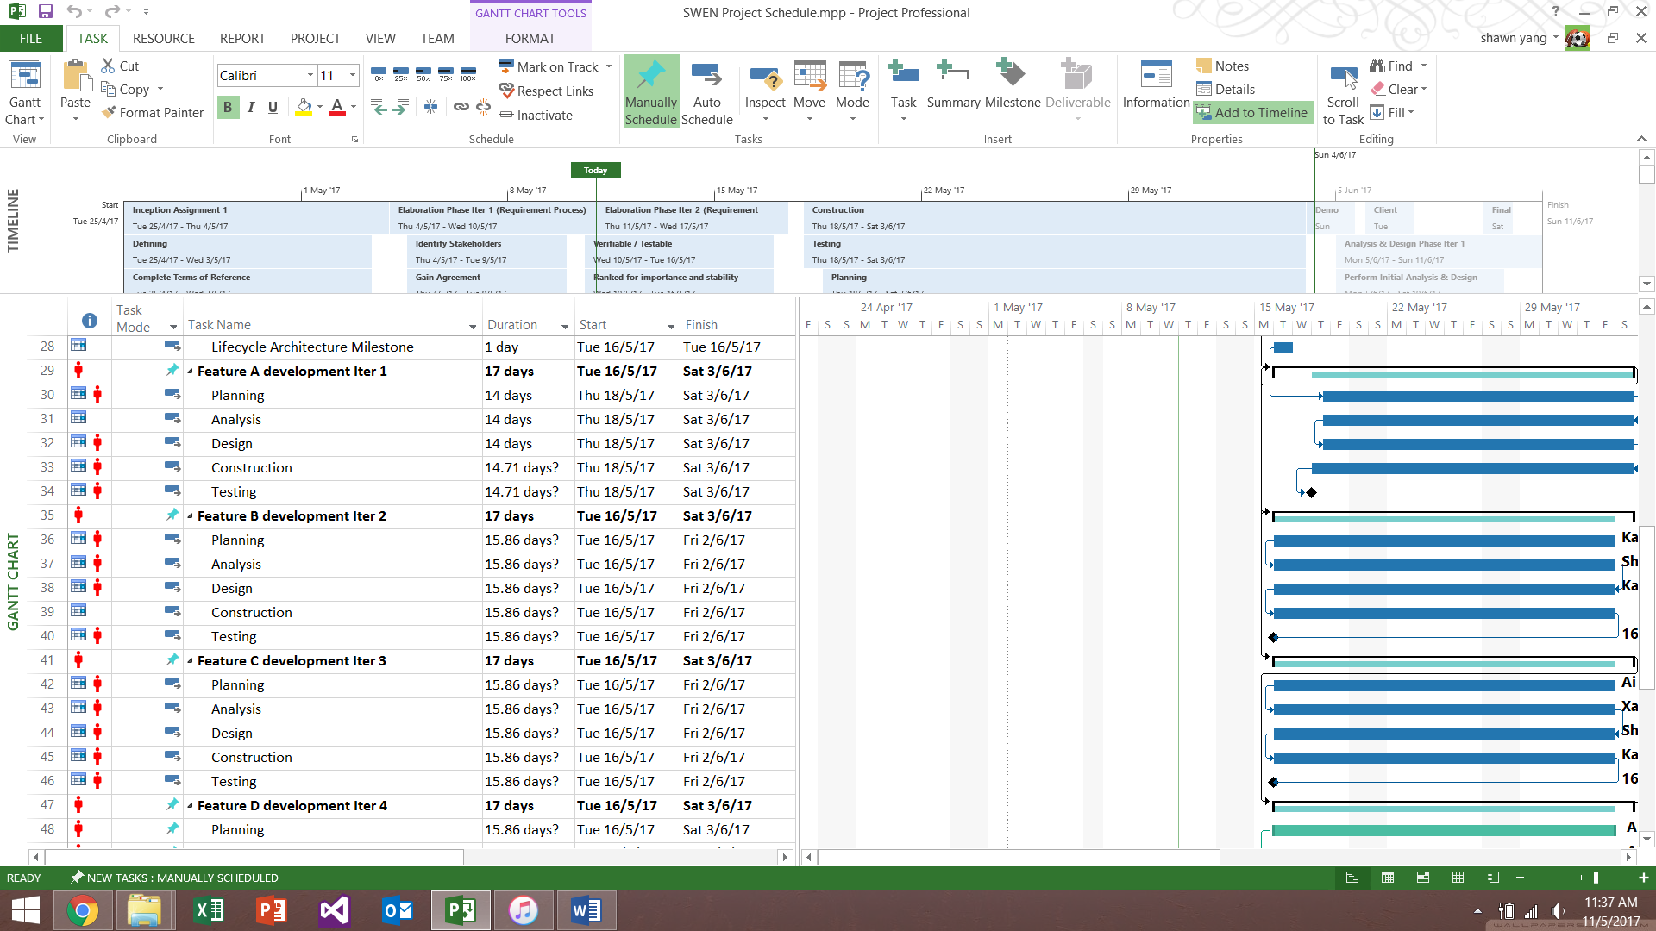

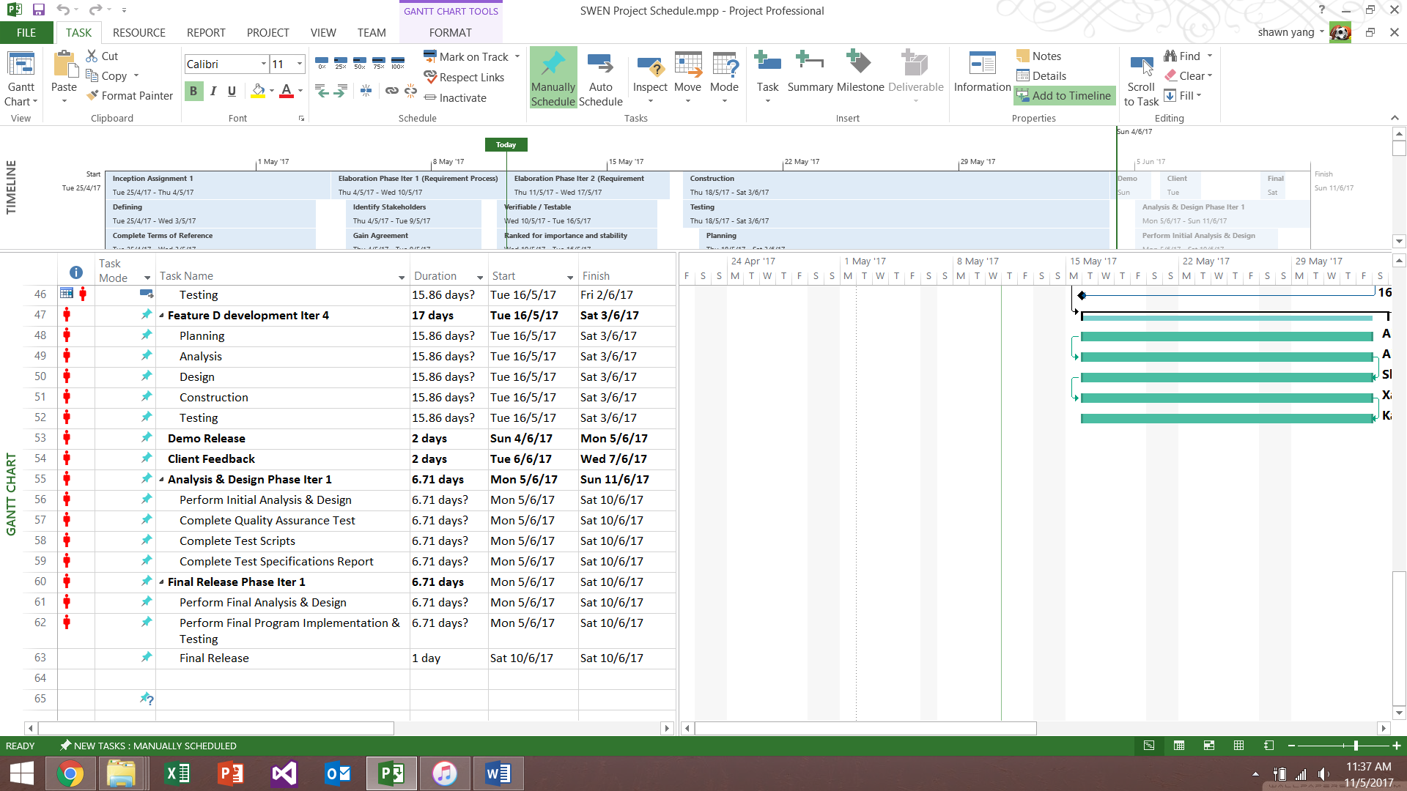

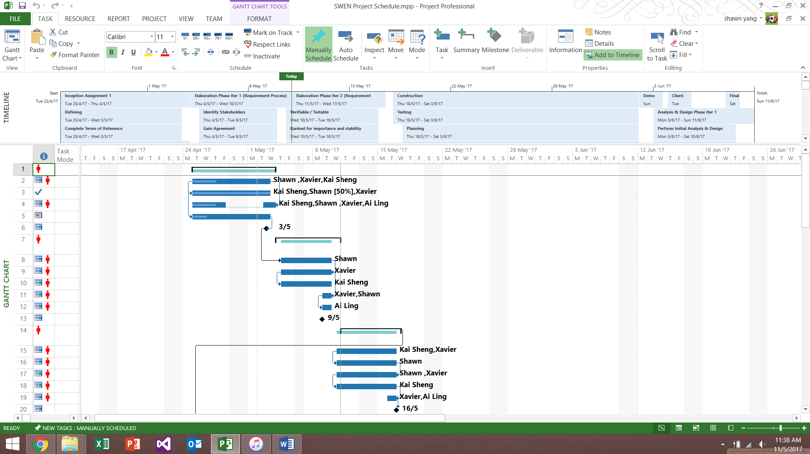

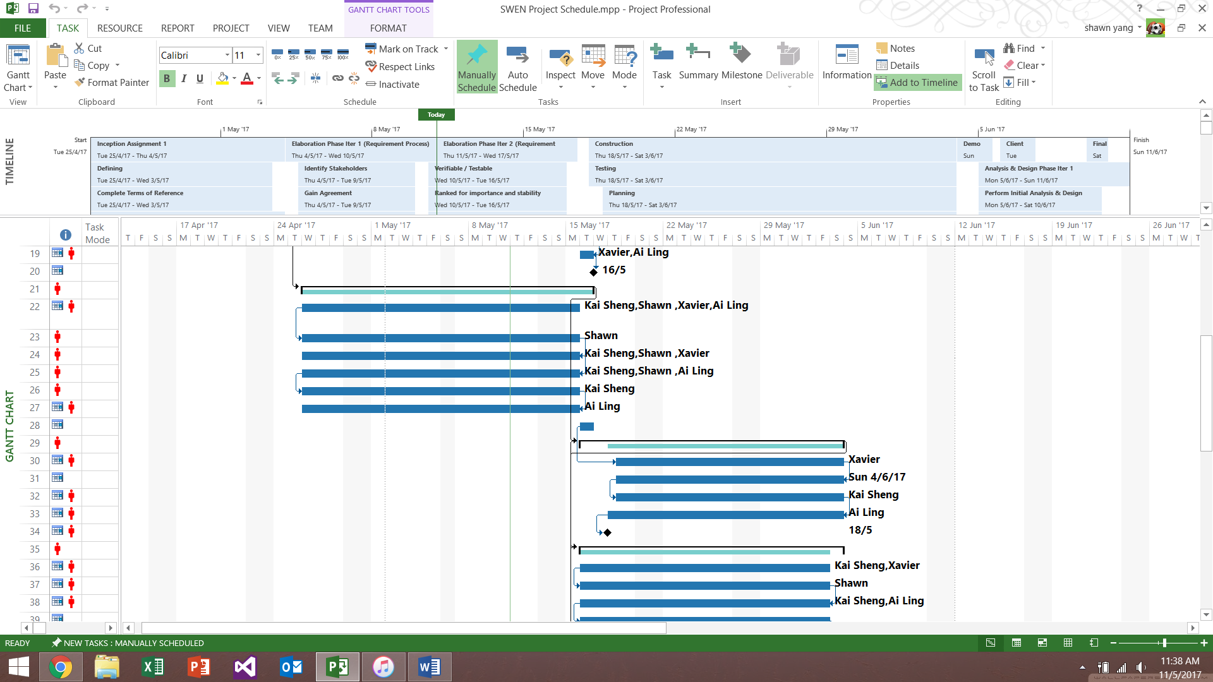

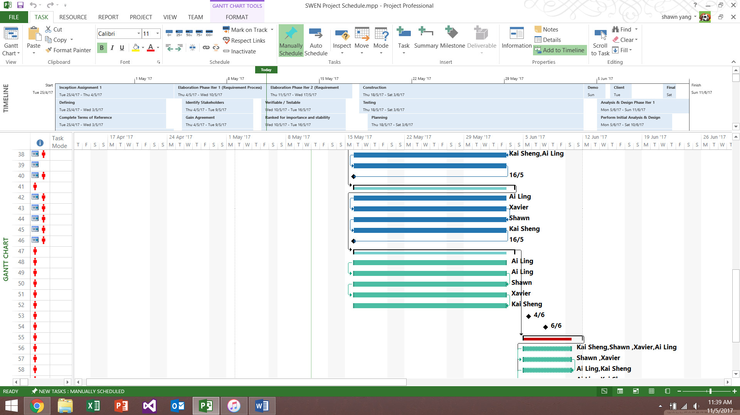

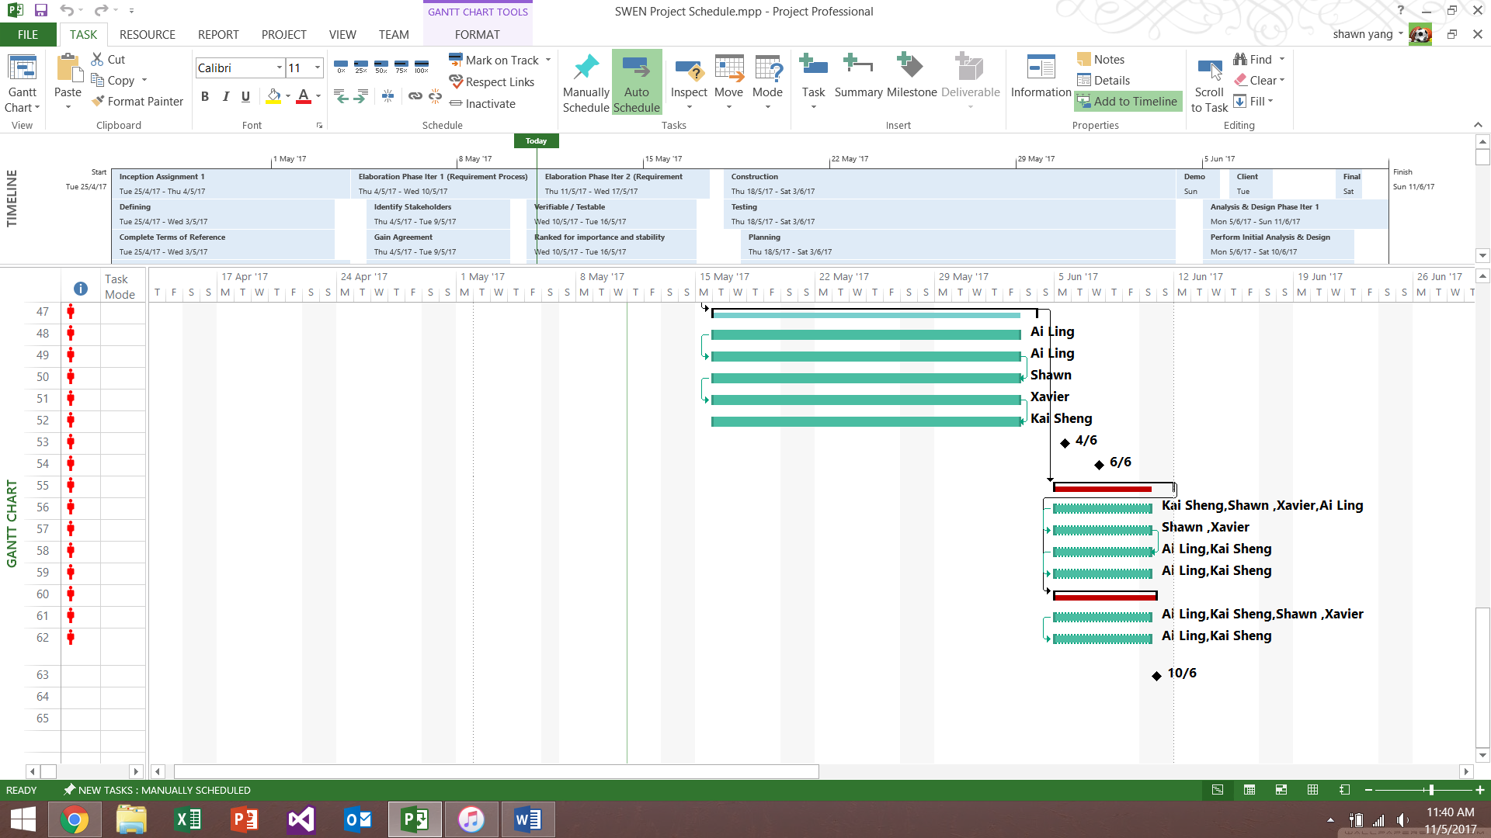

## Budget Summary

|  |  |  |
| --- | --- | --- |
| **Budget Summary** | | |
| **1)** **Manpower Costs** | | |
| Type: | Monthly Salary: | Duration of project: |
| 3 Software Engineers | 3 X $3,900 = $11,700 | 8 Weeks/2 months |
| Project Manager | $5000 | 8 Weeks/2 months |
| 2 Software Testers | 2 X $2,900 = $5800 | 1 month |
| **2)** **Hardware Costs** | | |
| Type: | Cost: |  |
| Server | $5000 |  |
| Bluesocket (Wi-fi Installation) | $500-600 |  |
| 4 Computers (Reception) | $3200 |  |
| 2 Printers (Reception) | $200 |  |
|  |  |  |
| **3)** **Software Costs** | | |
| Type: | Costs: |  |
| Microsoft Visual Studio Enterprise (1 year) | $1,199 |  |
| Microsoft Project Standard 2016 | $909.99 |  |
| Rational Functional Tester (12 Months) | $7000 |  |
| Android Studio | Free |  |
| Google Cloud Storage | $0.026 |  |

**Manpower Costs**

For the manpower costs, we will split the budget with the project manager having 45% and the software engineers having 55% of the budget. Additionally, we will have 2 software testers for last month of the project to check for bugs and defects

**Hardware Costs**

We decided to use $5000 on a server so that data and information can be stored easily. We also decided to use $500 for Bluesocket, a virtual wireless LAN for hotel users and also the employees to use the Wi-fi. Additionally, $3200 will be spent on 4 computers for the receptionist as well as 2 printers for emergency in case the internet booking could not be done by the customers.

**Software Costs**

We will use $1,199 of the software costs budget on Microsoft Visual Studio to create and design the website for customers to browse and do their online booking. We will use $909.99 on Microsoft Project 2016 to create the project schedule. In addition, $7000 of the software costs budget will be spend on Rational Functional Tester for 1 year in order to test the hotel management system for any defects and bugs. We will use Android Studio to create the mobile application for Delonix Regia. Lastly, we will use Google Cloud Storage to store all information and data.

# Risk Management Plan

